**EXP NO: 16**

**Aim:** To Change Hardware compatibility of a VM (Either by clone/create new one) which is already created and configured.

**Implementation:**

1.install and setup VM ware software and create a new virtual machine

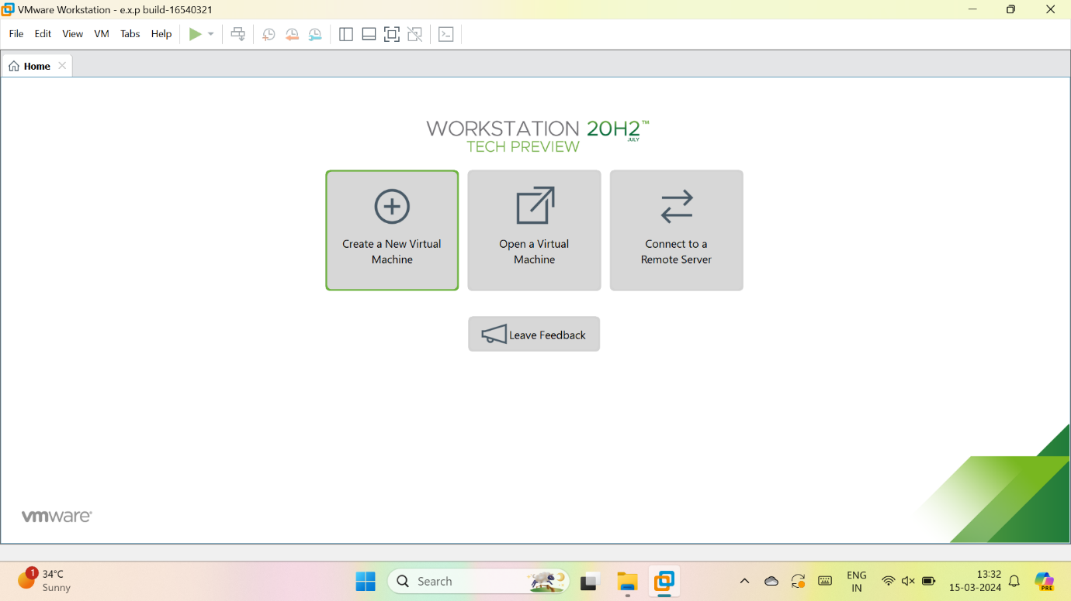

2.select typical

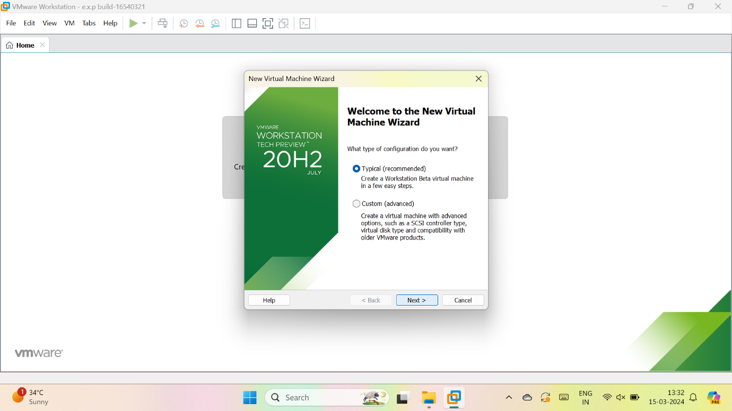

3.we have to select, I will install the OS later

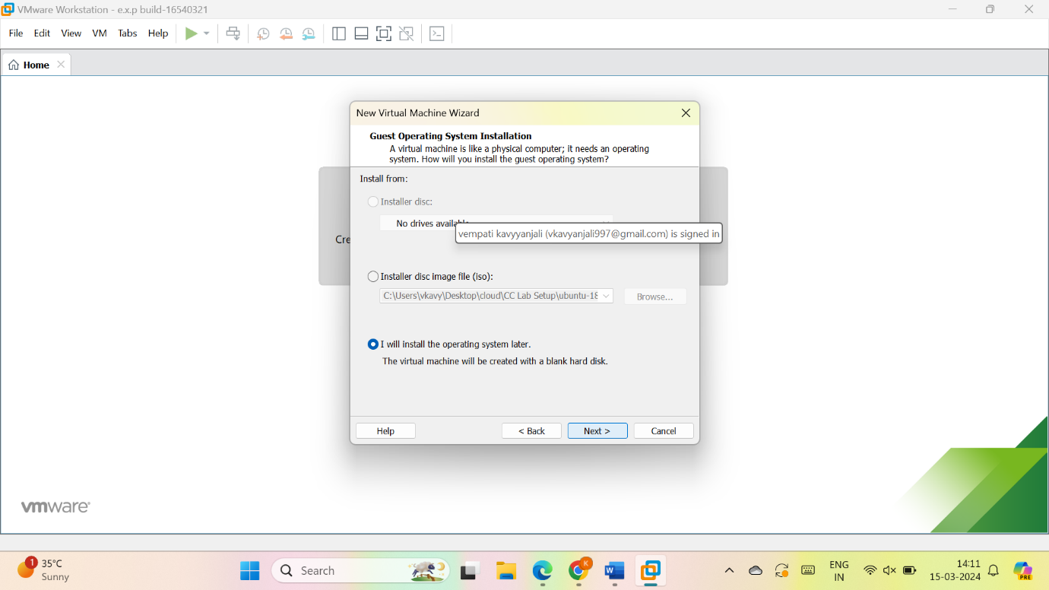

4.give name for VM

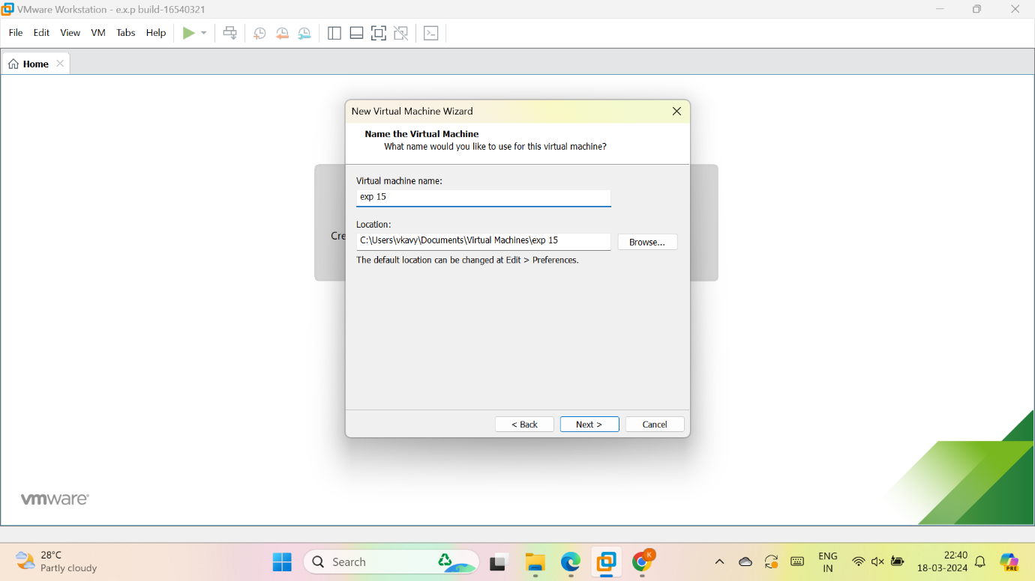

5.give the maximum size of disk and store virtual disk as a single file and give next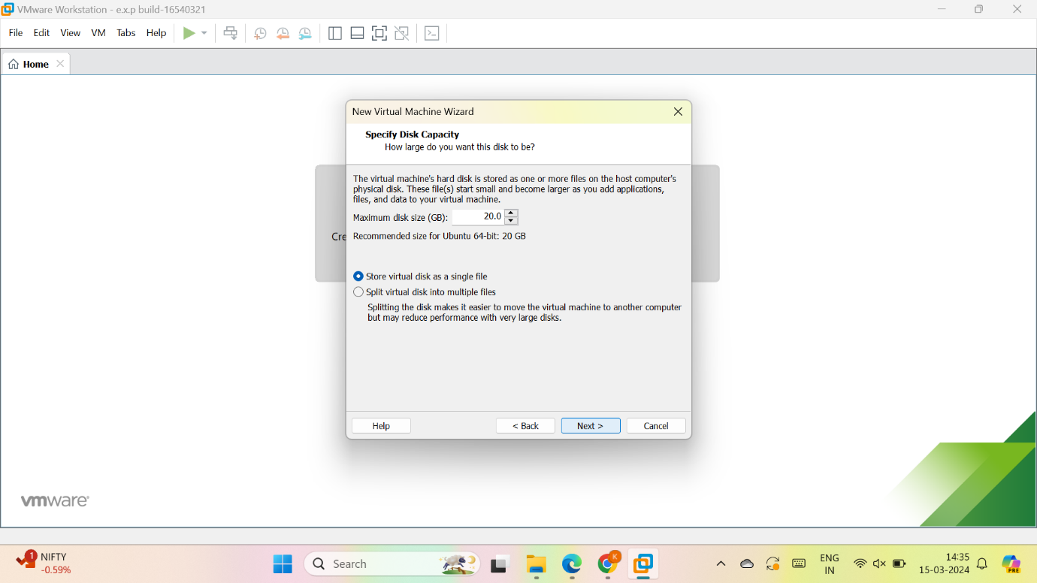

6.check the description

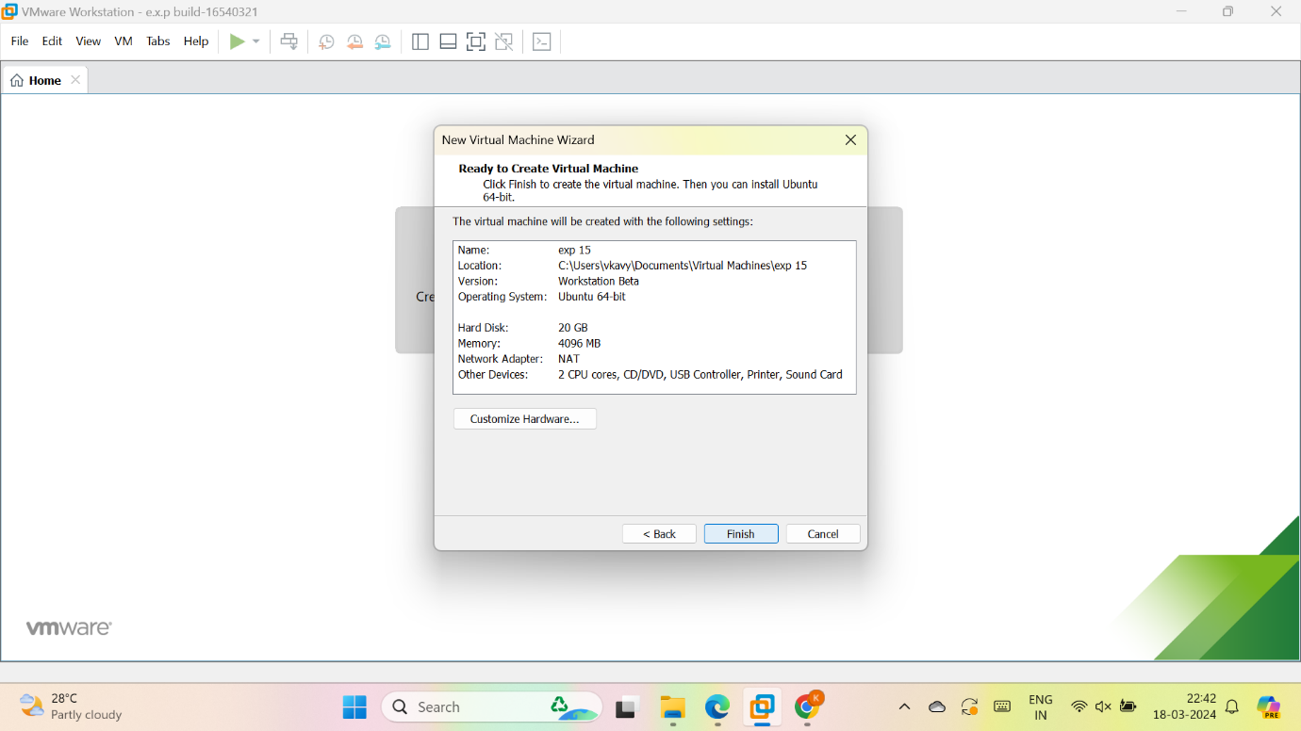

7.vm is created

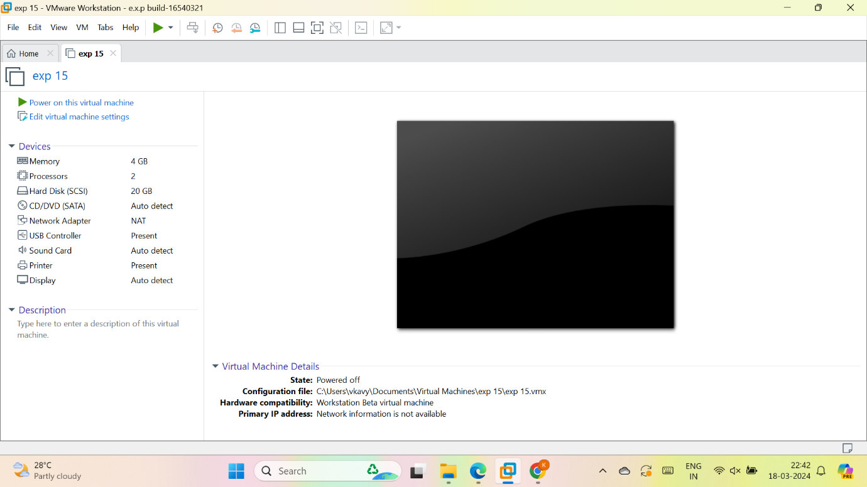

8. As per given question we have to Change Hardware compatibility

Select any hardware to change

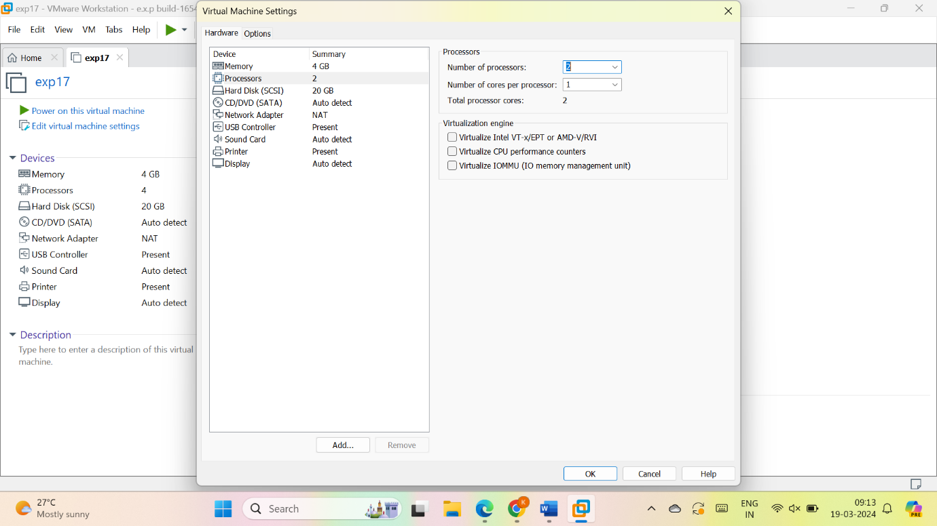

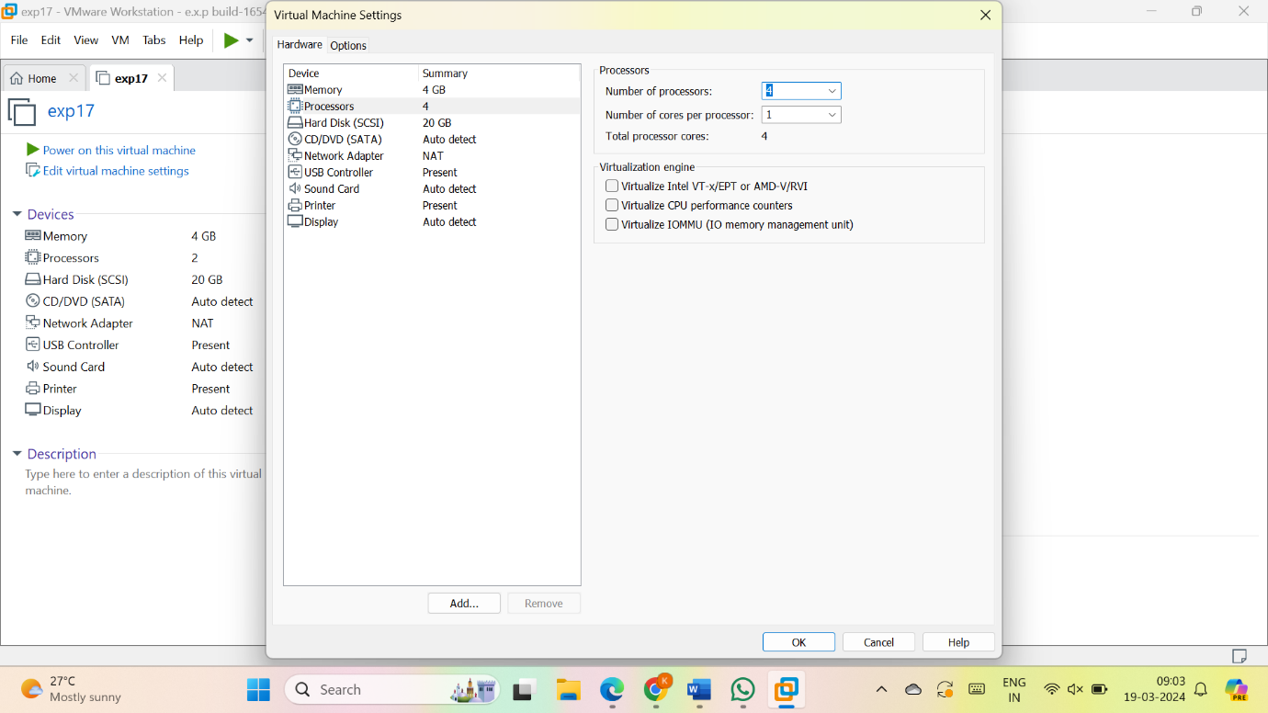

**RESULT:**

The processor is changed

